Software Requirements Specification

Version 1.0

December 07, 2018

Mind Healing Website

Deena Davis -1640121
Subhasree V-1640141
Sugin Varghese - 1640177

Submitted in partial fulfillment
Of the requirements of
COMPUTER SCIENCE PROJECT

Introduction

We aim to make a website that will benefit people who are either clinically

Depressed or go through mood swings in their everyday lives. The website will

function like a psychologist so near and close to you.

Keeping a mood diary can be a valuable component of treatment for
Psychological disorders including bipolar disorder, major depression, and anxiety. This website provide a systematic and portable means of rating mood symptoms over time, and allow the user to better understand how emotional states vary with thoughts, behaviours, and experiences.

  - Project description

Project is to create a website which provides online psychological support to

people who need help. This projects will have the help of psychologists who are

ready to help and volunteers who will help to link patients with psychologists. The

website will play as mind refreshments.

Users can rate their moods by swiping a bar to the left or to the right in the

website. It is also possible to give them various options out of which they can select

one option. A calendar with the moods of the person will also be shown with different

colors associated with each different mood. The person can either take a copy of this

monthly report, show it to their doctor so that the doctor can do better diagnosis or

keep it with him for self-analysis.

Existing system
There are website which works similar to this project. They are providing online

support to keep people happy by providing different activities and games. Very few

websites are providing personal support.
1.3. Proposed system

This project will help you connect with a psychologist unlike other websites.

We will also provide chat support and telephonic conversation with psychologist. The

Patient will be undergoing an analysis by one of the volunteers to make sure that the

patient gets proper support and help.

  - Objectives

The website intend to develop positive psychology in the person by instilling certain amount of gratitude towards life in him. He/ She will also be asked to do certain simple good deeds each day to gain a positive outlook of life. A check mark will be provided against the good deeds so that they get to know.
1.5 Purpose, scope and applicability

1.5.1 Purpose

The purpose of this document is to present a detailed description of the Website.
It will explain the purpose and features of the system, the interfaces of the system, what the system will do, the constraints under which it must operate and how the system will react to external stimuli. This document is intended for both the stakeholders and the developers of the system.

1.5.2 Scope of Project
This website will be for people who are having psychological disorders. This website will be designed to provide maximum support to people going through such disorders like Bipolar disorder, anxiety and depression etc. By using all the latest advancements in psychology to meet the daily needs of patient the website will remain easy to understand and use.
More specifically, this system is designed to allow volunteers and psychologists to help and communicate with a group of patients. The website will facilitate users to share their mood by selecting options. Preformatted responses are used to make the user feel better; the responses will include motivational quotes, soothing songs. The system also contains a database containing information of the users who register through the app.
1.5.3. Applicability
This website could be used by many industries specially IT industries to help their employees and reduce stress in the work environment to make the environment more productive. This website can also be used by psychology clinics to keep track of the mood of their patients.

1.6. Glossary
Term | Definition
Database | Collection of all the information monitored by this system.
Admin | The person who can access the database and change the data stored in the database.
Field | A cell within a form.
Volunteer | The person who helps to connect patient with a psychologist.
Client | Anyone visiting the site.
psychologist | A trained person who can give mental and psychological support to people.
Patient | The person visits the website to seek help of a psychologist.
Software Requirements Specification | A document that completely describes all of the functions of a proposed system and the constraints under which it must operate. For example, this document.
.

System analysis and requirements

2.1 Problem definition

The website intends to solve the problem faced by people with various psychological disorders. Due to hectic schedule various people are facing several mental issues and are not able to function constructively. This website intend to solve such issues to make people more productive and happy in their daily lives.

2.2 Use cases
Volunteer

Psychologist

Admin

Database Manager

User Module

Administrator module

Dhyana

Patient

Figure 1 - System Environment

2.2.1 Patient use cases
Register
patient
Login/logout
Enter mood details
Request Support
View monthly Calander

Use case: Register his/her details
Diagram:

Patient

Register

Brief Description
The patient accesses the Dhyana Website, choose the register option and enter his details.

Initial Step-By-Step Description
Before this use case can be initiated, the patient has already accessed the Dhyana by giving the URL

- The patient chooses to register to the website by selecting the Register Option.
- The system displays the registration form.
- The patient fills the form.
- The system validates his entries.
- The patient then clicks submit button.
- The system takes the patient to home page.

Register
Chooses His/her Mood
SYSTEM
Help
Songs are played

Figure 2 - Article Submission Process

The process state-transition diagram summarizes the use cases listed below. A patient registers in the website by giving his details. He/she chooses the mood to which he can relate his present state, from the given options. The website plays soothing songs, display quotes which can make the patient better. Either the patient feels better or he/she is still not feeling better and an option will be provided where psychologist support can also be provided. If that option is not possible volunteers will be arranged who can visit the patient and understand his/her situation.

Use case: Chooses an option that best suits patient’s mood

Diagram:
patient
Chooses the option

Brief Description
The patient chooses an option that relates to his/her mood.

Initial Step-By-Step Description
Before this use case can be initiated, the patient has already connected to Dhyana Website using the URL

- The System displays the options.
- The patient chooses an option using a radio button or check box.
- The System displays quotes or play songs that can calm the patient down or if he/she is happy the system tries to make that moment more special.
- The System also records his daily moods and add this to the calendar.

Use case: Notes down the things the patient is grateful for

Diagram:

Patient

Grateful Notes
Brief Description
The patient notes down the grateful moments he/she had that day.

Initial Step-By-Step Description
Before this use case can be initiated, the patient has already connected to Dhyana Website using the URL
- The System has an option for the patient to write notes.
- The patient selects that option.
- The System displays the note section.
- The patient writes his feelings on the note section.

Use case: Request for psychologist support or get address of nearby psychologists.
Diagram:

Brief Description
Patient
Request Support
The patient requests for a psychologist support if possible or get the address of nearby psychologist.

Initial Step-By-Step Description
Before this use case can be initiated, the patient has already connected to Dhyana Website using the URL

- The patient requests for psychologist assistance.
- The System checks the availability.
- The System provides the nearby psychologists address and timings.
- The User clicks on the links to get more details.

2.2.2 Volunteer Use Case
In case of multiple volunteers, this term refers to the main admin, who makes all major changes.

Use case: Register
Diagram:

Brief Description
Volunteer
register
The volunteers will be registering and their details will be stored in a database.

Initial Step-By-Step Description
Before this use case can be initiated, the volunteer has already connected to the Dhyana Website.
- The system will show the option for a volunteer registration.
- The volunteer selects the register option, fill in his details and click submit.
- The details will be stored in the database.

Use case: Connects to patients through phone

Diagram:
volunteer
Connects to patient

Brief Description
The volunteers will be given a notification when somebody is requesting for help.

Initial Step-By-Step Description
Before this use case can be initiated, the volunteer has already connected to the Dhyana Website.

- The system will decide whether the need of a volunteer exists or not based on the
mood ratings of the patient .
- If the mood rating exceeds a certain value patient will be connected to an available volunteer over a phone.
- If the volunteer is able to connect to the patient he will update the database to store that information.

Use case: Requests psychological support for the patient.

Diagram:
Patient
REQUEST
Psychologist

Brief Description
The volunteer analyses the condition of the patient and requests for psychological support, if necessary.

Initial Step-By-Step Description
Before this use case can be initiated, the volunteer has already accessed the main page of the Dhyana Website.

- The volunteer connects to the patient over phone and analyses his/her situation.
- The volunteer also submits the mood rating of the patient to the system.
- The volunteer will decide whether or not the patient needs psychological support and he/she will connect to a psychologist to request chat support for the patient.
- The volunteer informs the patient about the updates.
- The system verifies the information.

2.2.3 Psychologist Use Case

Use case: Register his/her details
Diagram:
Psychologist
Register
Brief Description
Psychologist register his/her details.

Initial Step-By-Step Description
Before this use case can be initiated, the Reviewer has already connected to Dhyana Website.

- The system displays the psychologist register option.
- Psychologist register into the website with their details which include education, years of experience and their schedule.
- The Psychologist submits the details.
- The System stores the information in a secure database.

Use case: Provide chat support to patients
Diagram:
Psychologist
Provides Chat Support
Brief Description
The Psychologist provides chat support to the patients on request.

Initial Step-By-Step Description
Before this use case can be initiated, the psychologist has already accessed the main page of Dhyana website.

- The psychologists provide their phone number of any social media messaging platform .
- The psychologists connects to patients through chat support only when the volunteer has requested for it, on knowing about the patient’s condition.
- The System stores the information of this communication.

Admin use cases

Use case: Create database
Diagram:
Admin
Create Database
Brief Description
Admin decides the database schema and creates a database depending upon the necessity.

Initial Step-By-Step Description
Before this use case can be initiated, the admin has already analyzed the needs of end users.

- The admin decides the database schema.
- The admin creates the database structure.
- The admin provides necessary validation for the data.

Handle data

Use case: Change database structure or some data.
Diagram:
Admin
Changes Database Structure
Brief Description
The admin changes the database structure if needed.
Initial Step-By-Step Description
Before this use case can be initiated, the admin has access to database.

- The admin analyses the manipulations to be made in the database.
- The admin accesses the database.
- The admin makes necessary changes in the database structure using DDL and the data using DML.

Use case: Grant privileges or restricts access.

Diagram:
Admin
Restrict
Access
Unauthorised Users
Brief Description
The admin decides what privileges to be granted and who should get access to the webpages.

Initial Step-By-Step Description
Before this use case can be initiated, the admin has already decided the privileges or restrictions.

- The admin makes changes in the website
- Administrative privileges enable users to manage operation of the MySQL server. These privileges are global because they are not specific to a particular database.
- Information about account privileges is stored in the grant tables

2.3 Requirements Specification

2.3.1 External Interface Requirements
The links to an external system are the links to the nearby psychological clinics and meditation centers. The Database fields of interest to the Web Systems are patients’ name and email address (an optional field for the HS Database).

2.3.2 Functional Requirements
This section outlines the use cases for each of the patient separately. The

Volunteer, the patient and the psychologist are the users where patient is the main actor

Logical structure

2.3.2.1. Patient use case
Use Case Name | Patient use case
Trigger | Patient register his/her details
Precondition | The Web is displayed with grids for registering
Basic Path | - The Patient chooses how to register.  - The system displays the registration form.  - The patient fills the form.  - The system validates his entries.  - The patient then clicks submit button.  - The system takes the patient to home page.
Alternative Paths | If the Patient selects to register, the system displays registration form.  After the patient complete the registration the system will validate the entries.  .  When the data is validated and stored in the database, the system takes the patient to home page.
Postcondition | The patient is provided with multiple options to enter his mood details
Exception Paths | The Patient may abandon the registration at any time.

2.3.2.2 Enters mood details
Use Case Name | Enters mood details
Trigger | The patient clicks the given link to enter the mood details
Precondition | The patient is on the “Enter mood details” page linked from the home page.
Basic Path | This use case uses the mailto HTML tag. This invokes the patient email facility.
Alternative Paths | If the user prefers to use his or her own email directly, sufficient information will be contained on the Web page to do so.
Postcondition | The details are entered.
Exception Paths | The attempt may be abandoned at any time.
Other | None

2.3.2.3 Note down the things user is grateful for
Use Case Name | Note down the things user is grateful for.
Trigger | Clicks the “notes” section to enter the things patient is grateful for.
Precondition | The patient has accessed the notes section.
Basic Path | - The System has an option for the patient to write notes.  - The patient selects that option.  - The System displays the note section.  - The patient writes his feelings on the note section
Alternative Paths | If in step 2, either field is blank, the Editor is instructed to add an entry. No validation for correctness is made.
Postcondition | The ‘grateful things’ are added to the database.
Exception Paths | The Patient may abandon the operation at any time.

2.3.2.4 Requests for psychologist
Use Case Name | Request for psychologist.
Trigger | The patient selects to request for a psychologist.
Precondition | The system checks the availability for a psychologist.
Basic Path | - The patient requests for psychologist assistance.  - The System checks the availability.  - The System provides the nearby psychologists address and timings.  - The User clicks on the links to get more details.
Alternative Paths | If there is no psychologist available the reader is sent a message regarding the same.
Postcondition | The request accepted time has been added to the database.
Exception Paths | The patient may abandon the operation at any time.

2.3.2.5 Volunteer use case
Use Case Name | Volunteer use case
Trigger | The volunteer selects to register to the website.
Precondition | The volunteer has accessed the registration page.
Basic Path | - The system will show the option for a volunteer registration.  - The volunteer selects the register option, fill in his details and click submit.  - The details will be stored in the database.
Alternative Paths | In step 5, if any required field is blank, the patient is instructed to add an entry.
Postcondition | The database has been updated.
Exception Paths | The volunteer may abandon the operation at any time.

2.3.2.6 Connects to patient through phone
Use Case Name | Connects to patient through phone.
Trigger | The volunteer selects to connect to the patient though phone.
Precondition | The volunteer will get the contact number of patient.
Basic Path | 1.. The system will decide whether the need of a volunteer exists or not based on the mood ratings of the patient .  2. If the mood rating exceeds a certain value patient will be connected to an available volunteer over a phone.  3. If the volunteer is able to connect to the patient he will update the database to store that information.
Alternative Paths | Songs are played to soothe the patient.
Postcondition | The database has been updated.
Exception Paths | The patient may refuse to have a conversation with the volunteer.

2.3.2.7 Request psychological support for the patient
Use Case Name | Request psychological support for the patient.
Trigger | The volunteer selects request support for the patient.
Precondition | The volunteer analyses the condition of the patient
Basic Path | - The volunteer connects to the patient over phone and analyses his/her situation.  - The volunteer also submits the mood rating of the patient to the system.  - The volunteer will decide whether or not the patient needs psychological support and he/she will connect to a psychologist to request chat support for the patient.  - The volunteer informs the patient about the updates.  - The system verifies the information.
Alternative Paths | None
Postcondition | Receives the help of a psychologist.
Exception Paths | unavailability of psychologist.

2.3.2.8 Psychologist use case
Use Case Name | Register his/her details
Trigger | The psychologist selects to register his details.
Precondition | The psychologist has accessed the registration page.
Basic Path | - The system displays the psychologist register option.  - Psychologist register into the website with their details which include education, years of experience and their schedule.  - The Psychologist submits the details.  - The System stores the information in a secure database.
Alternative Paths | None.
Postcondition | Psychologist details has been entered to the data base.
Exception Paths | The psychologist may abandon the operation at any time.

2.3.2.9 Provide chat support to patients
Use Case Name | Provide chat support to patients
Trigger | the psychologist has selected to provide chat support to patients..
Precondition | the psychologist has accessed the contact number of patient.
Basic Path | - The psychologists provide their phone number of any social media messaging platform .  - The psychologists connects to patients through chat support only when the volunteer has requested for it, on knowing about the patient’s condition.  - The System stores the information of this communication.
Alternative Paths | None.
Postcondition | System stores the information of this communication.
Exception Paths | The psychologist may abandon the operation at any time.

2.3.2.10 Create database
Use Case Name | Create database
Trigger | Selects create database option.
Precondition | Admin decides the database schema
Basic Path | - The admin decides the database schema.  - The admin creates the database structure.  - The admin provides necessary validation for the data.
Alternative Paths | None.
Postcondition | Database has been created.
Exception Paths | The admin may abandon the operation at any time.

2.3.2.11 Change database structure or some data
Use Case Name | Change database structure or some data.
Trigger | Selects to change the data in the database.
Precondition | the admin has accessed the database to make changes in it.
Basic Path | - The admin analyses the manipulations to be made in the database.  - The admin accesses the database.  - The admin makes necessary changes in the database structure using DDL and the data using DML.
Alternative Paths | None.
Postcondition | the database structure has been changed
Exception Paths | The admin may abandon the operation at any time.

2.3.2.12 Grand privileges and restricts access
Use Case Name | Grand privileges and restricts access.
Trigger | The admin selects to restricts access.
Precondition | The admin has accessed the website.
Basic Path | - The admin makes changes in the website  - Administrative privileges enable users to manage operation of the MySQL server. These privileges are global because they are not specific to a particular database.  - Information about account privileges is stored in the grant tables
Alternative Paths | None.
Postcondition | The data access is restricted.
Exception Paths | The admin may abandon the operation at any time.

2.3.3 Data flow diagram
DFD of Admin
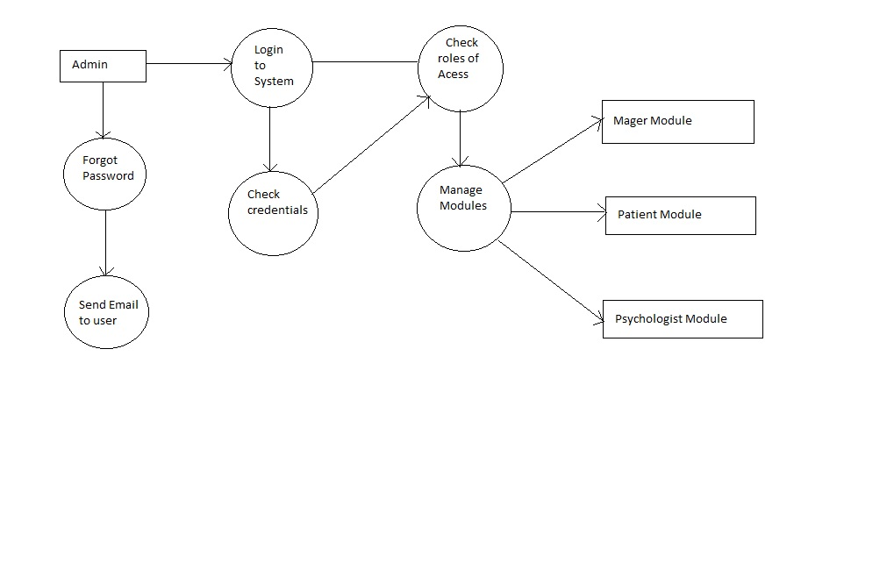
DFD of Patient
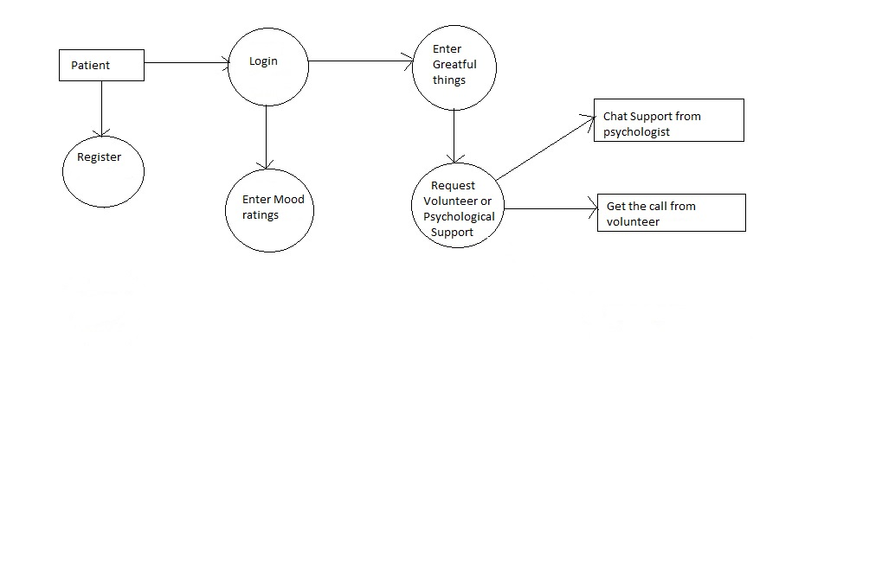

DFD of volunteer
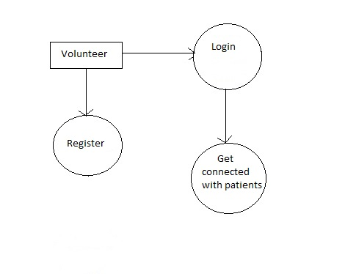
DFD of psychologist
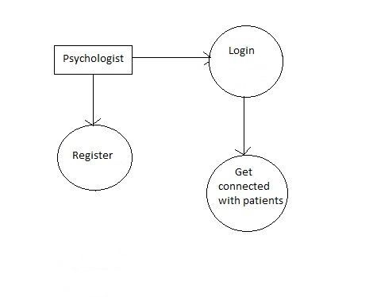
The data descriptions of each of these data entities is as follows:

Patient Data Entity
Data Item | Type | Description | Comment
Name | Text | Name of principle author
Email Address | Text | Internet address
Phone no: | integer | Contact number | May be several

Volunteer Data Entity
Data Item | Type | Description | Comment
Name | Text | Name of the volunteer
ID | Integer | ID number | Used as key
Email Address | Text | Internet address

Psychologist Data Entity
Data Item | Type | Description | Comment
Name | Text | Name of the psychologist
Email | Text | Internet address
Schedule | Date | Schedule of psychologist

Security
The server on which the websites sides will have its own security to prevent unauthorized write/delete access. There is no restriction on read access.
The PC on which the database resides will have its own security. Only the Admin will have physical access to the machine and the program on it. There is no special protection built into this system.

2.3 Block diagram
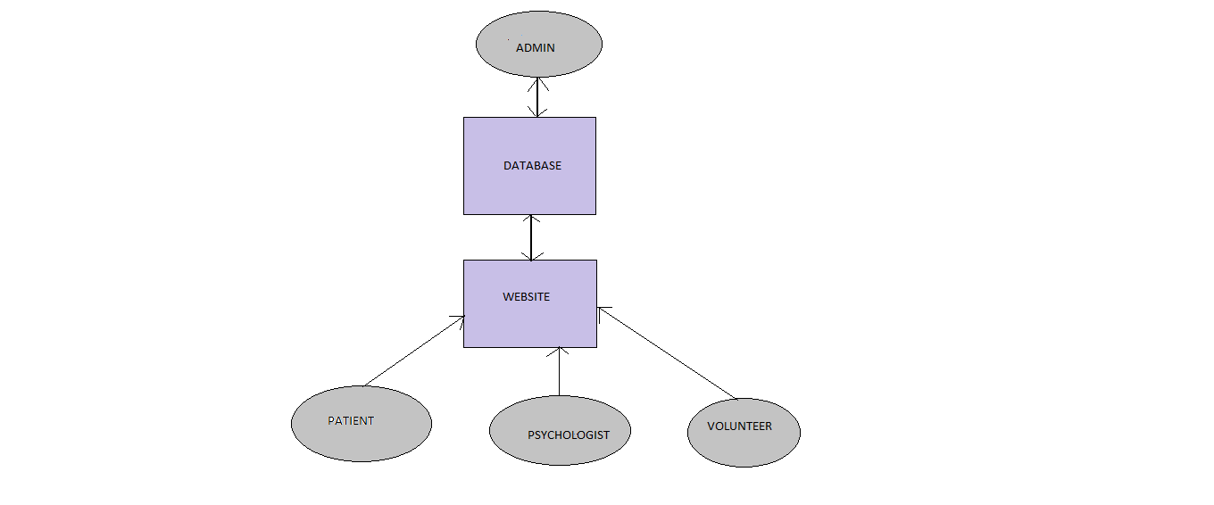
2.4 System requirements

2.4.1 User Characteristics
The patient is expected to be Internet literate and be able to use the search engine. The main screen of the Website will have the search function and a link to “Psychologists’ websites.”
The volunteer and psychologists are expected to be Internet literate and to be able to use email with attachments. The psychologists should be able to enter their details and be aware of the facilities of the website and their duties.

    - Software and hardware requirements
2.4.2.1. Software requirements

- Bracket
- Xamp
- notepad++
- notepad

Programming Languages used:

- HTML
- JavaScript
- CSS
- SQL
- PHP

2.4.2.2. Hardware requirements

- Personal System
- Memory

2.4.3. Constraints

The project has certain limitations. Risk management becomes very necessary when dealing with people who are depressed or facing certain psychological disorders. There are also chances of getting fake support requests. The system must thus be able to distinguish between genuine and fake cases. A limited budget is another common constraint because we may have to pay the psychologist some money in the future for their services.

